On Valentine’s Day, the Orioles entered into a relationship with Andrew Cashner to the tune of two years for $16 million, much to the chagrin of some of his ex’s (Rangers) fans. Both SBNation’s site of the Texas Rangers, [LoneStarBall](https://www.lonestarball.com/2018/2/11/17001978/texas-rangers-rumors-andrew-cashner-mlb-free-agency), and beat writer Evan Grant, [recommended a Cashner reunion](https://sportsday.dallasnews.com/texas-rangers/rangers/2018/02/10/rangers-neverseriously-pursued-yu-darvish-free-agency) at one point or another this offseason. By looking at some of Cashner’s raw statistics from his 2017 campaign, it could be argued, albeit wrongly, that he was one of, if not the best, pitcher on the Ranger’s staff. For the sake of this entire analysis, I will be using data from [FanGraphs](https://www.fangraphs.com/). There are some data discrepancies, especially with batted ball data and WAR, between FanGraphs and BaseballReference, which is why I am only using FanGraphs data for consistency.

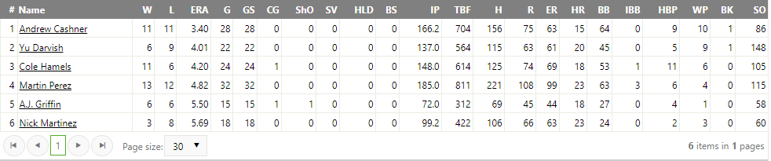

Among qualified starters for the Rangers, pitchers with at least 70 innings pitched (IP), Cashner had a 3.40 ERA and 11 Wins, which were first and second best among the staff respectively. However, these metrics are skewed and do not tell the whole story about the competence of a pitcher.

There are many problems with pitcher Wins as a metric of pitcher ability. You can read passionate tirades against it [here](https://www.fangraphs.com/tht/lets-get-rid-of-pitching-wins/) and [here](http://waitingfornextyear.com/2013/08/overrated-baseball-statistics-pitcher-wins/) for example. In essence, why should one pitcher be rewarded for the work of an entire team? Winning a baseball game is half the responsibility of the offense after all, and at least a quarter on the defense and relievers, so why should a pitcher be rewarded or penalized by an arbitrary stat? A pitcher can pitch a great game and still not get “the win”. For an extreme example, in 1959, Harvey Haddix of the Pittsburgh Pirates pitched 12 perfect innings against the Milwaukee Braves, only to [lose the game](http://www.history.com/this-day-in-history/haddix-pitches-12-perfect-innings-but-loses) on a two-run double by Braves’ first baseman Joe Adcock in the 13th inning. 36 batters up, 36 batter retired, yet Haddix still did not get a Win.

However, I am not here to rail against wins. Instead, I want to point out how ERA can be skewed, and why luck, and the inherent randomness in baseball, can impact a player’s season.

ERA stands for “Earned Run Average” and is the average of the number of “earned runs” a pitcher allows per nine innings. Not every run that crosses home plate during a pitcher’s stint on the mound counts as an “earned run” however. No, an [“earned run”](https://en.wikipedia.org/wiki/Earned_run) is any run that was fully enabled by the offensive team's production in the face of **competent play** from the defensive team. A pitcher has no control over the competence of his defense. There are many examples of good pitchers pitching for bad teams, and this can result in inflated ERA’s and skewed Win totals. This can be seen with Cashner, who in 2017, only had 84% of his runs allowed be “earned”, by far the lowest on the staff. What we need then, is a way to measure a pitcher’s skill, without worrying about any balls put into play that are the responsibility of the defense.

Luckily, the smart people of the sabermetric community [developed such a metric](http://www.sportingnews.com/mlb/news/what-is-fip-era-pitching-baseball-mlb-stats-statistics-advanced-sabermetrics/d5p48p6z6us51lqbo0wvgigto), lovingly known as FIP. [FIP](https://en.wikipedia.org/wiki/Defense_independent_pitching_statistics#FIP), which stands for Fielding Independent Pitching, exists to remove the effects of fielding from the equation and only look at the aspects of the game that the pitcher can control. FIP improves for each strikeout a pitcher obtains, and penalizes a pitcher for each homerun, walk, and hit batter, all weighted accordingly. This number is then divided by innings pitched, and then a FIP constant is added. The [FIP constant](https://www.fangraphs.com/guts.aspx) is based on the league average FIP and the league average ERA, and is the same for all pitchers. The purpose of the constant is to scale the metric so it is similar to, and can be interpreted the same as, ERA. This means both FIP and ERA operate on the same scale, where around 5.00 is poor, 4.00 is about average, 3.00 is good, and below 3.00 is getting into Cy Young territory.

If you were to compare the FIP of pitchers to their ERA, you would notice that many of them have ERAs that are close to their FIP. John Smoltz ended his career with an ERA of 3.33 and a FIP of 3.24. [New Ranger](https://sportsday.dallasnews.com/texas-rangers/rangers/2018/02/04/rangers-bartolo-colon-close-minor-league-contract) Bartolo Colon has a career 4.02 ERA and a career 4.06 FIP. Pedro Martinez finished with an ERA of 2.93 and 2.91. Almost everyone finishes their MLB careers with a minimal difference between their FIP and their ERA. This can be seen even at a season wide level.

Since this is a more statistically oriented site, it is important to point out that since FIP only measures things in a pitcher’s control, its variance is smaller than that of a noisy stat like ERA. For 20 years, from 1997-2016, I calculated the FIP for each team at the end of the season and compared it to their ERA. I am able to make the assumption that the team ERA and FIP are approximately Normal because of the [Central Limit Theorem](https://en.wikipedia.org/wiki/Central_limit_theorem). While no single team ERA or FIP across those years may necessarily be Normal, by summing them together, we can see that they are approximately Normal.

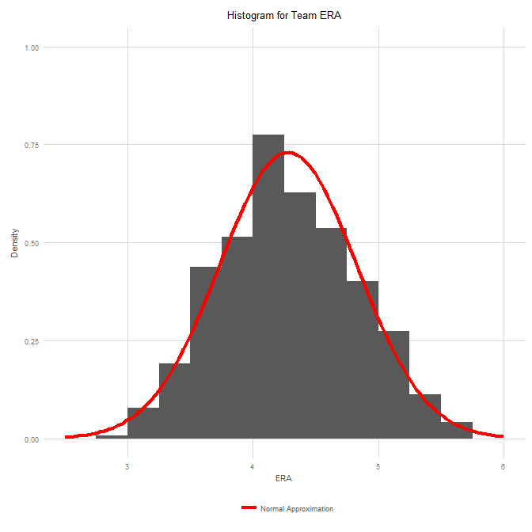 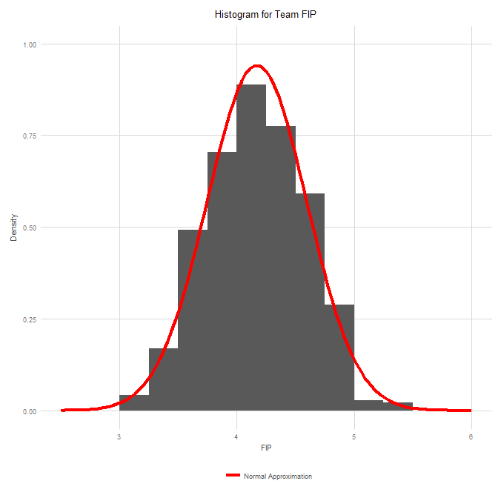

The team ERA had a mean of 4.27, with a variance of 0.293. This means that ~95% of team ERAs fell between 3.19 - 5.36, or a range of 2.17. The team FIP, on the other hand, had a mean of 4.17, with a variance of only 0.177. This means that ~95% of team FIP’s fell between 3.38 - 5.0, or a range of 1.68. The distribution of team FIP is much narrower than that of team ERA. By building a linear regression between FIP and team runs allowed, we can also see that FIP is a decent predictor of runs allowed. The correlation is a high 0.87, with an R^2 value of 0.757.

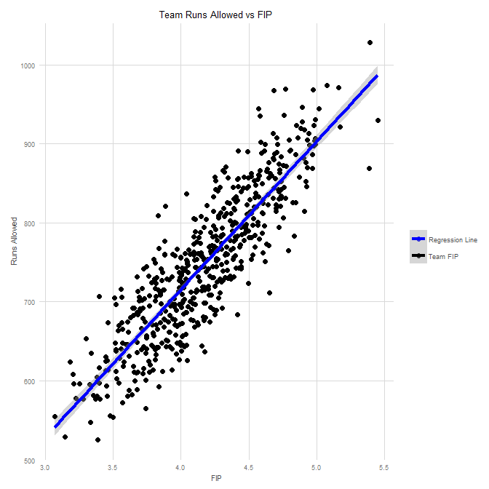 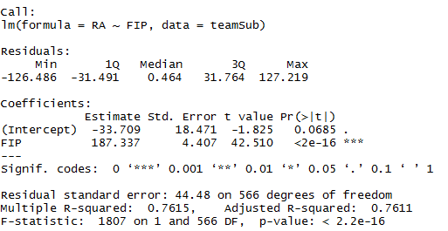

Sure, but no team would field a team of pure Andrew Cashners, I hear you muttering. Don’t fret, I narrowed my population down then to single pitchers with over 120 IP per season between 1997-2016 and compared their FIP to ERA. The results are below.

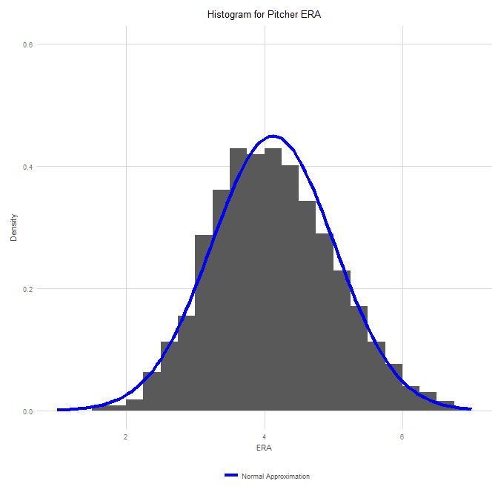 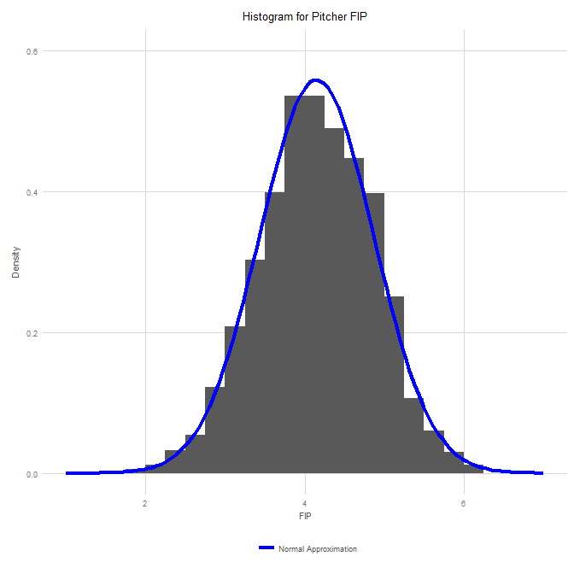

Again, we can see that the distribution of pitcher FIPs is much narrower than that of pitcher ERAs, due to a smaller variance. Pitcher ERA had a mean of 4.12 with a variance of 0.79. 95% of pitcher ERAs fell between 2.35 - 5.9, or a massive range of 3.55. FIP, on the other hand, had a mean of 4.15, with a variance of 0.51. 95% of pitcher FIPs fell between 2.72 - 5.57, or a range of 2.85. If you were wondering, the correlation with pitcher runs allowed was only .46, with an R^2 of 0.21. This is because there is much more inherent randomness within single pitcher runs allowed than an entire team, and one statistic can only explain so much variance. ERA only had a correlation of .60 with runs allowed, with an R^2 of 0.36, which is odd if you think about it, since ERA is supposed to encapsulate the damage of runs allowed.

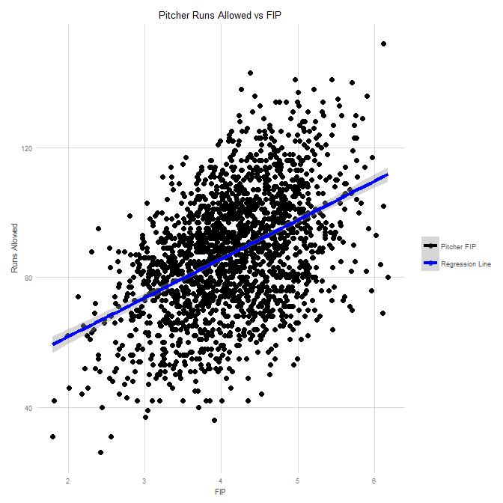 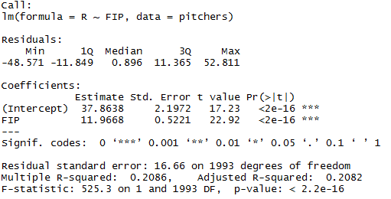

By looking at the difference between FIP and ERA, we can see if the above observation that ERA and FIP tend to converge is true. For those of you who already compared the means for pitcher ERA and FIP, we can already make that assumption.

The mean of the difference FIP - ERA is .02, quite close to 0, with a variance of 0.32. 95% of the difference in pitcher FIP and ERA fell between -1.11 and 1.16. With this knowledge then, we can come to the conclusion that a large difference between a pitcher’s ERA and FIP is probably unlikely, and the probability of a pitcher’s ERA outperforming their FIP multiple times is nearly zero.

Since the mean of the difference is essentially zero, we can also assume that over a large enough sample size, ERA and FIP will converge. While monthly ERA and FIP might differ, or even whole seasons, over the course of a career or multiple years, we would expect to see such convergence in the two metrics. This is a phenomenon known as [regression towards the mean](https://en.wikipedia.org/wiki/Regression_toward_the_mean).

What does all of this have to do with Andrew Cashner? Well, [here](https://www.fangraphs.com/statss.aspx?playerid=8782&position=P) are his ERA, FIP, and FIP-ERA stats from 2013-2017.

|  |  |  |  |
| --- | --- | --- | --- |
| Year | ERA | FIP | FIP - ERA |
| 2013 | 3.09 | 3.35 | 0.26 |
| 2014 | 2.55 | 3.09 | 0.54 |
| 2015 | 4.34 | 3.85 | -0.49 |
| 2016 | 5.25 | 4.84 | -0.41 |
| 2017 | 3.40 | 4.61 | 1.21 |

One of those years is not like the others. His average FIP – ERA from 2013-2016 is -0.025, essentially 0. That obviously changes in 2017.

In fact, Cashner’s whopping 2017 FIP – ERA of 1.21 is so large, the probability of it occurring was only 2%! Only around 40 single season pitchers in the 20 years examined, out of a total population of approximately 2,000 qualifying pitchers, had a difference that high. The likelihood of Cashner outperforming his FIP by such a margin again in the future is thus miniscule.

For his career, Cashner has a 3.8 ERA and a 3.99 FIP. In 2018, we should expect a regression towards those statistics as well as a closer career ERA and FIP. In fact, his FIP might outperform his ERA to cancel out the extreme difference of 2017.

So what could explain such a discrepancy? Well, two metrics that strongly signify luck benefitted Cashner in 2017. These were BABIP and HR/FB%. BABIP is the batting average of balls in play, and usually hovers around .300. A pitcher that strongly outperforms their career BABIP is likely to regress the following season. Further, HR/FB% measures the percentage of flyballs that turn into homeruns. The league average is around 10%, and again, outperforming this metric strongly implies regression the next year. BABIP and HR/FB% are two metrics a pitcher should not be able to control. For example, [Clayton Kershaw had a HR/FB% of 15.9%!](https://www.fangraphs.com/statss.aspx?playerid=2036&position=P#battedball) This is well above his career average, and so we should expect this value to drop tremendously next season.

Cashner had a 0.26 BABIP, where his career is 0.290, and a HR/FB% of 8.6%, to a career rate of 10.6%. These numbers are further confounded when taken with the context that Globe Life Park is a hitter’s park, [second only to Coors Field](http://stations.espn.go.com/mlb/stats/parkfactor?year=2017) in run park factor. The [Rangers staff](https://www.fangraphs.com/leaders.aspx?pos=all&stats=sta&lg=all&qual=70&type=2&season=2017&month=0&season1=2017&ind=0&team=13&rost=0&age=0&filter=&players=0&sort=8,a) had an average HR/FB% of 13.4%, and an average BABIP of 0.275.

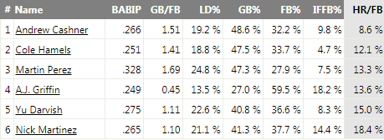

We can see from the graph below that a 0.26 BABIP is quite rare from pitchers over the 20 year sample, further indicating a high probability of regression in 2018.

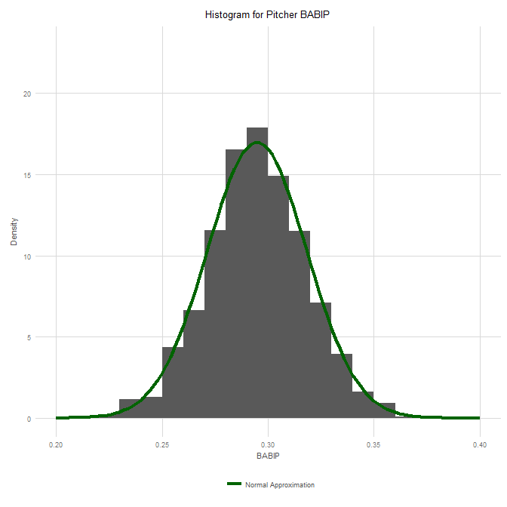

Here are two charts, provided by FanGraphs, that show Cashner’s career ERA/FIP and BABIP/HR/FB%. BY looking at the years 2013-2017, it is evident he outperformed his true ability last season and regression is inevitable.

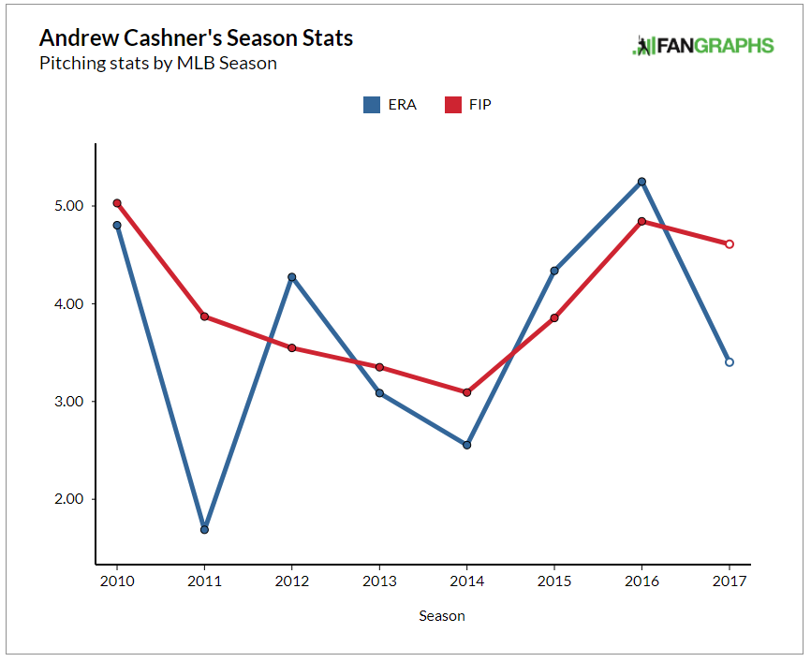 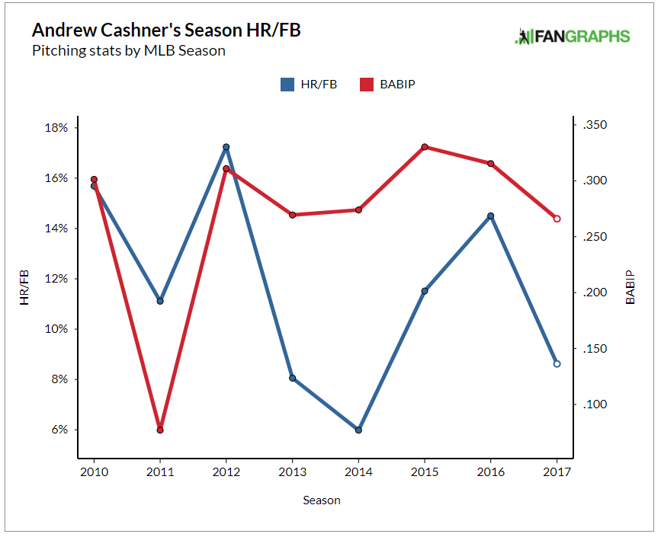

In summary, Cashner had fewer balls in play fall for hits, and less fly balls turn into homeruns than expected, as seen by other pitchers on the staff. Further, the probability of Cashner’s ERA outperforming his FIP, which measures only things the pitcher can control, by such a large margin again is slim to none. These differences indicate Cashner had a lucky 2017 campaign, and his metrics are unsustainable for future play. These lucky seasons are expected to happen, that is part of the wonderful randomness of baseball, but a repeat is highly unlikely.

If you want a different argument for why Cashner will regress in 2018, I highly recommend [The Orioles Are Paying Money to Andrew Cashner](https://www.fangraphs.com/blogs/the-orioles-are-paying-money-to-andrew-cashner/), by Jeff Sullivan. Here, Jeff looks at Cashner’s plummeting strikeout percentage, and his xFIP, a more fancy and predictive version of FIP accounting for a player’s HR/FB%.

What do you think? Will Cashner help the Orioles in the AL East and force Rangers’ fans to inwardly groan? Or will he regress closer to his career norms? I know I, at least, won’t be drafting him for my fantasy team this year…

The SaberSmart Team

<https://twitter.com/lonestarball/status/964281697415106561>